Course Project Final Visual Analysis Thesis

Shaun Pritchard

Rasmussen College

Author Note

This research is being submitted on February 3,2021 for Adam Mrozewski’s G332 Visual Communication in the Media course.

**Final Visual Analysis Project – Thesis**

This analysis will be based on the design factors for a professional UI toolkit called Flutter for building web and native mobile and desktop applications. Flutter UI is a (UI) User Interface framework created by Google that uses the Dart programming language which is similar to the javascript programming language but simplified. Flutter offers a promise of fast development, native mobile and desktop performance, and flexible UI/UX to create amazing user experiences. According to Flutter UI, their framwork allows developers to focus on building expressive user experiences instead of focusing on the abstraction of programming.

**Example 1** -- The analysis of the five perspectives will demonstrate how the visuals used in Flutter UI website work together to create an emotional user experiance to persuade viewers to download their products and use their frameworks.

**Example 2** – The analysis of the five perspectives will demonstrate how the visuals elements in Flutter UI website will enhance the viewer’s understanding of the concepts through graphical communication methods.

**Example 3** – The analysis of the five perspectives will demonstrate how powerfull simplistic (less is more) minimal geometric design concepts can be effective in retaining communication and user attention while providing a great user experience.

***Thesis Statement****:*

With the use of five perspectives, Flutter UI website will demonstrates how animations, visuals, and user exeriance design concepts work together to create an emotional connection with users to persuade them to download their products and use their framework.

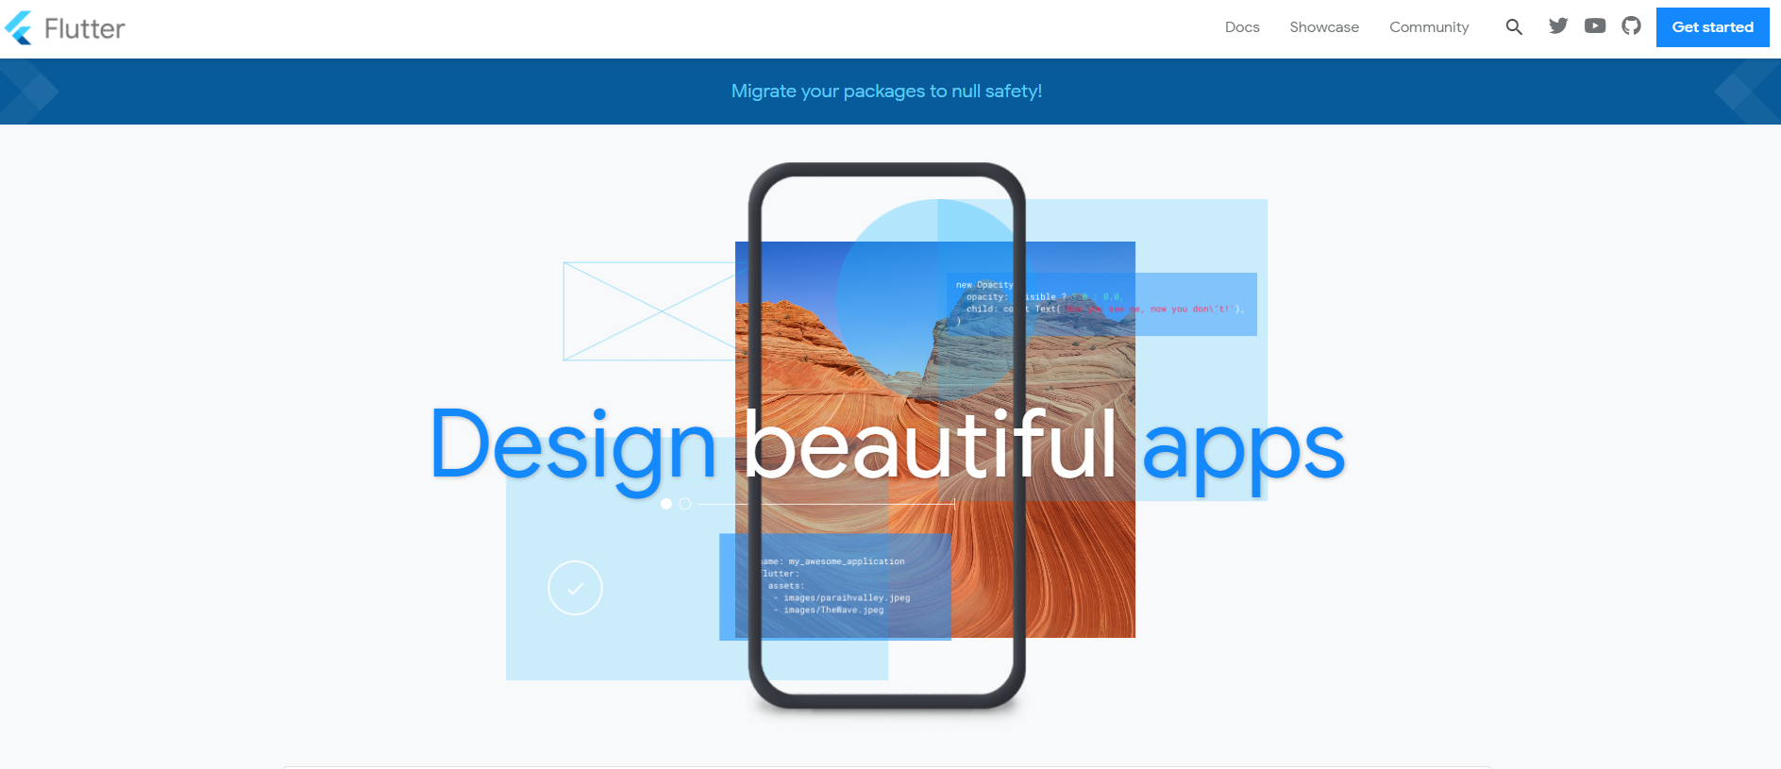

*Img-1:1*, (Google, 2020)

**Final Visual Analysis Outline**

1. **Introduction**
   1. Visual communication and media the new communication medium. Currently 2.8 billion social media users worldwide. This means that over a third of the world’s population is using some form of visual media to communicate. Through this, interpreting sensory imagery which impacts impact product design encourages mental stimulation, brandon packs, and trust of brands and people (Facebook, 2020).
   2. Data Shows that 90 percent of the information transmitted to the brain is visual, and visuals are processed 60,000x faster in the brain this allows to people to retain more information flaster. This emphasizes the importance of visual communication. Also, data shows 46.1 percent of people say a website’s design is the number one criterion for discerning the credibility of a company (Amanda Sibley , HubSpot , 2017).
   3. With the use of five perspectives, Fluter UI demonstrates how visuals work to create an emotional user experiance to persuade viewers to download their products and use their UI framework (Google, 2020).
2. **Sensory Response** 
   1. Upon First Response viewing flutters homepage appears a soft medium-dark black rectangular framed outline of a mobile device. This is the only dark negative element on the page. flutter has implemented an intuitive animation slider design that allows images and transparent shapes to show up behind the frame.
   2. This allows the graphic to display multiple messages to promote the promises of the Flutter UI framework. The use of geometric shapes such as rectangles squares and circles divided prominent geometric lines that are layered over the main image using transparency and color themes designed to be harmonious, ensure accessible white text, distinguishes UI elements and surfaces from one another.
   3. The colors are used to implement a hierarchy of primary secondary light and dark variants for balance. The primary color is a bright blue which highlights and accents the features such as code blocks, icons, and creative UI elements in a very clean original design.
   4. While implementing strong dark blue horizontial line bar below the white menu header against a white negative space background gives the design balance and makes the design come alive and pop-out.
   5. Blue is implemented against a white negative background with transparency variant elements, which is typically a preferred color by many associated with trust, peace, water, tranquility, and reliability. upon viewing the website for the first time I get a sense of security and excitement that stimulates productivity, and creativity. Sensory perception transmits a message of similarity and proximity (Sheree Josephson, 2020).
3. **Perceptual Response**
   1. A perceptual analysis shows that the design is neutral in proximity. The initial overall perception gives results in an overall feeling of something new, exciting, simple, and futuristic. The graphic design elements use minimal imagery with a balance of actual clean geometric design elements. Implementing primary photos of landscapes with only a minimum amount of photos of people interacting with mobile devices with one another.
   2. The cultural familiarity of this web design is very neutral due to the geometric design Styles and patterns. Implementing the perception that this website is very open to all people from any walk of life with no preference on bias such as ethnicity or religion.
   3. Being that this is well known UI framework. It could be assumed that they are targeting those with familiarity with programming, graphics, and UI/UX Design. Social indication of this website design would appeal to those people who are more technical in retrospect. Such as graphic and visual designers, media connoisseurs, programmers, and coders. These occupations range across many different variations of societies on the planet. I felt this website did a very good job of keeping things neutral while marketing on a broad sense of appeal. Overall, this website brings a perception of strong visual hierarchies that guide visual logical progression and importance.
4. **Technical Response**
   1. Technically this website implemented minimal design with a center columned 3/4 full page using sectioned card design with consistent spacing to display very clean content.
   2. The initial menu header uses negative space with the logo in the left-corner while implementing 3 textual menu items and using clean dark social icons such as Twitter, YouTube, and GitHub followed by a clean blue button to start using their framework.
   3. Followed by the initial Above the fold header which uses web animations and the initial geometric header design what uses overlapping transparent colors in objects together. This animated header infamous the law of closure which suggests that objects are grouped or seen as a whole. The design is trying to show how much can be done to build a great looking application with minimal effort.
   4. Overall proximity suggests that the geometric lines fall the smoothness path. The design suggests reality is reduced to the simplest form. They did a great job of grouping content sections near each other appear to be grouped even with apparent spacing. Making this a simple but yet stimulating and intriguing design.
5. **Emotional Response** 
   1. The initial Emotional Response for this analysis is very neutral yet innovative. The colors are distributed evenly highlighting expressiveness and motion through an interactive environment that entices and intrigues the viewer.
   2. It sets a mood of reliability and expresses emotions that are Idyllic, Melancholy, and Ominous. Overall, they create a great user experience by implementing content on the page in a uniform fashion that aligns with telling a story.
   3. The design facilitates specific calls to action based around users implementing the framework or learning how to implement the framework plus facilitates information to inspire using the framework through its accomplishments.
   4. It contains 10 sections that implement web animations to highlight the veracity of implementing this framework, persuasive in the sense it minimizes complexity through its design features and perceptual organization.
   5. The persuasive elements on the page indicate how effortless and seamless using this application would be persuading the viewer the downloading this framework and implementing it to build their applications.
   6. Aside from animated the above the fold header section. Section-3, which has an interactive code sample shows users how seamless, easy, and minimal development is.
   7. Also, in section-6 implements use of more animations in the UI design comparing 2 mockup mobile devices side by side to show how fluidity and simplicity of the frameworks features.
6. **Ethical Response** 
   1. Flutter uses neutral stock photos of landscapes in geometric shapes. only one picture included in the design incorporated stock imagery of two women two men of multiple ethnicities using mobile devices
   2. Imagery suggest neutrality, professionalism and integrity of the company. The user can get a good perception of how the framework looks and feels with out stereotype or bias.
   3. Flutter appears to be open formed in targeting a broad-spectrum multi-cultural diverse user base. Specific to certain skill sets such as web, mobile, desktop application and UI development. flutter would most appeal to those with technical knowledge such as programming, graphic design, UI/UX design, and media.
   4. The interactive examples of framework usage do not depict any type of specific individual. The assumption can be being made that the company does assume a neutral role regarding the notion of users based on all races, nationalities, and origins. Prayer for claiming a neutral stance.
   5. The only limitations in diversity found are based on the only 1-image in the website that had people ranging from ethnicities of 2 white woman standing next to another white woman standing next to a black man who was standing next to a Spanish looking man. While women and men were both representing here this would indicate sexism is not apparent. Given the different ethnicities and genders. There where those that were not represented such Asians, black women, and other women of other races and cultures ethnicities were not represented. This was only one picture, though and it did do a good job representing diversity given the space requirements and marketing goal. If more images were added this could diminish the minimal design.
7. **Conclusion**
   1. With the use of five perspectives, Flutter UI demonstrates how using minimal design with animated and geometric visuals work to create an enticing emotional connection with users persuading them to download and use their framework application.
   2. Flutter has incorporated UI/UX best practices to facilitate sound implementations of emotional, sensory, technical, ethical, and perceptual responses throughout their website.
   3. Flutter appears to be open formed in targeting a broad-spectrum multi-cultural diverse user base. Specific to certain demographic of people with programmatic and graphic design skills.
   4. Overall, Flutter UI website design and brand uses simple minimalistic design practices delivering and clean expressive user experience.

# **References**

Amanda Sibley , HubSpot . (2017, Feb 03). *19 Reasons You Should Include Visual Content in Your Marketing [Data]*. Retrieved from https://blog.hubspot.com: https://blog.hubspot.com/blog/tabid/6307/bid/33423/19-reasons-you-should-include-visual-content-in-your-marketing-data.aspx

Facebook. (2020). *Facebook Reports Second Quarter 2017 Results*. Retrieved from https://investor.fb.com: https://investor.fb.com/investor-news/press-release-details/2017/Facebook-Reports-Second-Quarter-2017-Results/default.aspx

Google. (2020). *Flutter*. Retrieved from https://flutter.dev/: https://flutter.dev/

Sheree Josephson, J. D. (2020). *Handbook Of Visual Communication: Theory, Methods, And Media.* Routledge: Routledge/Taylor & Francis Group.